**INTERNET OF THINGS**

**BLIND SPOT MONITORING SYSTEM**

**Practical Activity**

# **CERTIFICATE**

This is to certify that a **Practical Activity** entitled with: “BLIND SPOT MONITORING SYSTEM” is being

**ABSTRACT**

The Internet of Things (IoT) connects a multitude of devices and systems to the internet, enabling seamless communication, data exchange, and intelligent decision-making

IoT revolves around the concept of interconnecting everyday objects, ranging from household appliances to industrial machinery, vehicles, and wearable devices, to create a networked ecosystem that fosters automation, data-driven insights, and enhanced user experiences. Through the integration of sensors, actuators, and communication protocols, IoT enables real-time data collection, transmission, and analysis, leading to informed decision-making and improved efficiency across various domains.

The Blind Spot Monitoring System (BSMS) is a crucial advancement in automotive safety, leveraging the Internet of Things (IoT) to address a critical issue: the detection and prevention of accidents caused by vehicles' blind spots. The integration of IoT technology enhances the capabilities of BSMS. By connecting the monitoring system to a larger network, information from multiple vehicles can be aggregated and shared, enabling proactive collision avoidance strategies. Additionally, cloud connectivity allows for over-the-air updates, ensuring that the system remains up to date with the latest algorithms and threat models.

BSMS utilizes a network of sensors, cameras, and communication modules strategically positioned around a vehicle to continuously monitor its surroundings. These sensors detect nearby vehicles, pedestrians, and obstacles, providing real-time data to a central processing unit. Through advanced signal processing and data analytics, the system identifies potential blind spot hazards and alerts the driver through visual, auditory, or haptic cues.

In conclusion, the Blind Spot Monitoring System within the IoT framework exemplifies the transformative potential of connected technologies in enhancing road safety.

**TABLE OF CONTENTS**

|  |  |
| --- | --- |
| **CONTENTS** | **PAGE NUMBER** |
| **ABSTRACT** | **i** |
| **LIST OF FIGURES** | **ii** |
| **LIST OF SCREENSHOTS** | **iii** |
| **1. INTRODUCTION** |  |
| **2. REQUIREMENTS** |  |
| **2.1 Hardware Components** |  |
| **2.2 Software Components** |  |
| **3. IMPLEMENTATION** |  |
| **4. RESULTS** |  |
| **5. CONCLUSION** |  |

1. **INTRODUCTION**

Blind areas, also known as blind spots, refer to the areas on the sides and rear of a vehicle that are not easily visible to the driver using the rearview and side mirrors. These blind areas can pose a potential danger, as they may prevent the driver from seeing nearby vehicles, pedestrians, or objects.

When a vehicle is in these blind areas, it becomes challenging for the driver to detect its presence through traditional mirrors alone.

The blind spot monitoring system is designed to enhance the safety of vehicles by providing visual feedback about the presence of objects in the driver's blind spots. In this mini project, we will be using an ultrasonic sensor and an LED strip to detect and indicate the presence of obstacles in the blind spot areas.

An ultrasonic sensor is a device that uses sound waves to determine the distance to an object. It emits high-frequency sound waves and measures the time it takes for the sound waves to bounce back after hitting an object. By utilizing this principle, we can detect the presence of objects in the blind spot areas of a vehicle.

To implement the blind spot monitoring system, we will integrate an ultrasonic sensor with an IoT development board such as Arduino or Raspberry Pi. The ultrasonic sensor will be positioned at an appropriate angle to cover the blind spot area. It will continuously measure the distance to nearby objects.

Whenever an object is detected within the specified range of the blind spot, the IoT board will trigger the LED strip to provide visual feedback to the driver ,indicating the presence of objects in the blind spot areas. The LEDs on the strip can be programmed to display different colors or patterns based on the distance or position of the detected objects.

For instance, the LED strip can light up in blue to indicate that the blind spot is clear, change to some other color if an object is detected at a moderate distance, or turn red if an object is very close.

By incorporating this blind spot monitoring system into a vehicle, we significantly enhance the driver's awareness of potential hazards in the blind spot areas. This system acts as an additional layer of safety, helping drivers make safer lane changes and turns, ultimately reducing the risk of accidents.

Implementing a blind spot monitoring system using an ultrasonic sensor and LED strip is an effective and relatively inexpensive way to improve overall vehicle safety. With its ability to provide real-time feedback on objects detected in the blind spot areas, this system greatly increases driver confidence and situational awareness on the road.

1. **REQUIREMENTS**

**2.1 HARDWARE REQUIREMENTS**

1. **Arduino UNO**

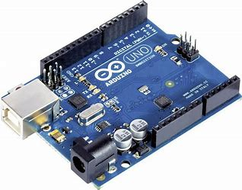

1. **Bread Board**

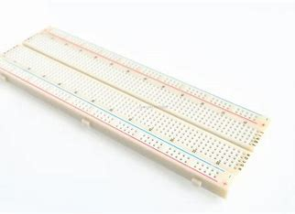

1. **RGB led Strip (1 meter**)

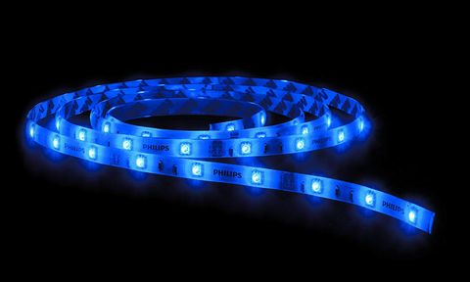

1. **HC-SR04 Ultrasonic Sensor**

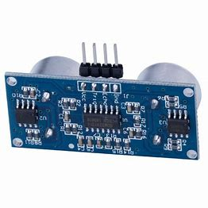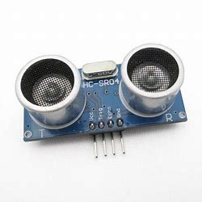

**2.2 SOFTWARE REQUIREMENTS**

**Arduino Ide Software:**

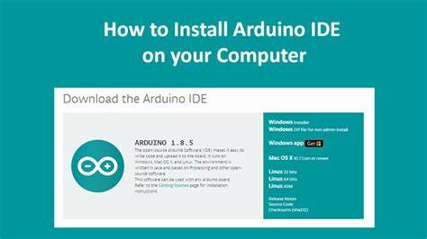

1. **IMPLEMENTATION**

**Code:**

//initializing the rgb strip pins

#define b 6 //blue

#define g 5 //green

#define r 3 //red

//initializing the ultrasonic sensor pins

#define echoPin 8

#define trigPin 12

//initializing the trigger distances of colour alerts

#define trigDist1 30

#define trigDist2 10

long duration;

int distance;

bool fade=true;

void setup() {

Serial.begin(9600);

pinMode(g,OUTPUT);

pinMode(b,OUTPUT);

pinMode(r,OUTPUT);

pinMode(trigPin, OUTPUT);

pinMode(echoPin, INPUT);

}

void loop() {

calDistance(); //calling the function that will calculate the distance

if(distance<=trigDist1 && distance>trigDist2){ //stage 1 trigger distance

fadedOrange(3);

fade=true;

}

else if(distance<=trigDist2){ //stage 2 trigger distance

fadedRed(3);

fade=true;

}

else{

fadeInBlue(); //idle

}

}

void calDistance(){

digitalWrite(trigPin, LOW);

delayMicroseconds(2);

digitalWrite(trigPin, HIGH);

delayMicroseconds(10);

digitalWrite(trigPin, LOW);

duration = pulseIn(echoPin, HIGH);

distance = duration * 0.034 / 2; //calculating distance using the distance = speed of sound * time taken/2

Serial.println(distance);

}

void fadedRed(int val){ //function to get a faded red blink

for(int i=255; i>0; i-=val){

analogWrite(r, i);

analogWrite(g, 255);

analogWrite(b, 255);

delay(5);

}

for(int i=0; i<255; i+=val){

analogWrite(r, i);

analogWrite(g, 255);

analogWrite(b, 255);

delay(5);

}

}

void fadedOrange(int val){ //function to get a faded orange blink

for(int i=255; i>0; i-=val){

analogWrite(r, i);

analogWrite(b, 255);

analogWrite(g, i>230?i:230);

delay(5);

}

for(int i=0; i<255; i+=val){

analogWrite(r, i);

analogWrite(b, 255);

analogWrite(g,i<230?240:i);

delay(5);

}

}

void fadeInBlue(){ //Blue fade in

if(fade==true){

for(int i=255; i>0; i-=1){

analogWrite(g, 255);

analogWrite(r, 255);

analogWrite(b, i);

delay(5);

}

}

fade=false;

analogWrite(g, 255);

analogWrite(r, 255);

analogWrite(b, 0);

**4. RESULTS**

**Below are the images of the hardware used :**

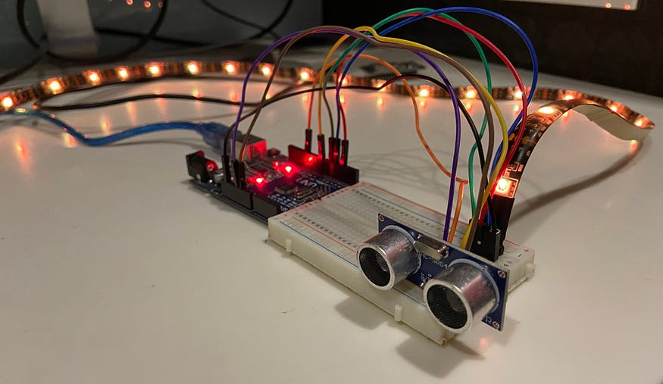

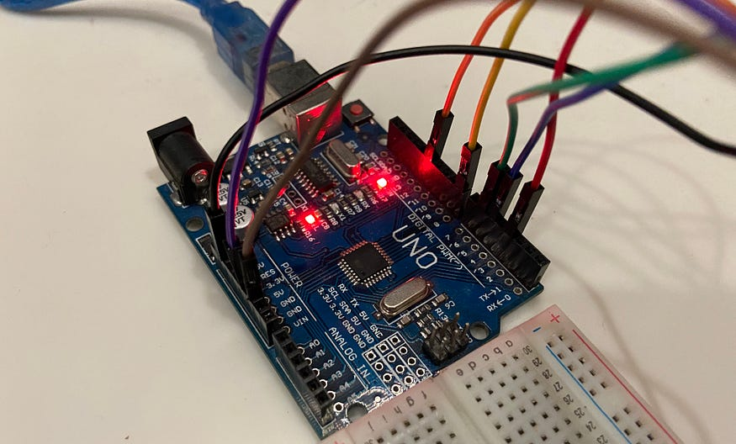

**5. CONCLUSION**

In conclusion ,the blind spot monitoring system implemented using an LED strip and an ultrasonic sensor provides a solution for detecting blinds spots in a given area. The system continuously measures the distance using the ultrasonic sensor and updates the led strip accordingly.

When a blind spot is detected, indicated by a distance measurement then the led strip is turned on depending upon the distance, this visual indicator serves to alter the user from potential danger. The implementation can be expanded based on our requirements for instance , additional features like buzzer/alarms can be incorporated to enhance the warning system.

Overall, the blind spot monitoring system using led strip and ultrasonic sensor offers a reliable and cost-effective solution for improving safety and reducing the risk of accidents in various scenarios where blind spot are a concern**.**